**Directions:**

Use this document to submit Phases I and II as a **single** PDF file titled “Last Name_First Name_Unit 2 Project_Phases I and II_Submission Document”.

**Phase I, Part 1**

Use Astah to draw a use case diagram. Use proper UML notation. When you have completed your diagram, take a clear screenshot of your diagram and paste it in the space provided.

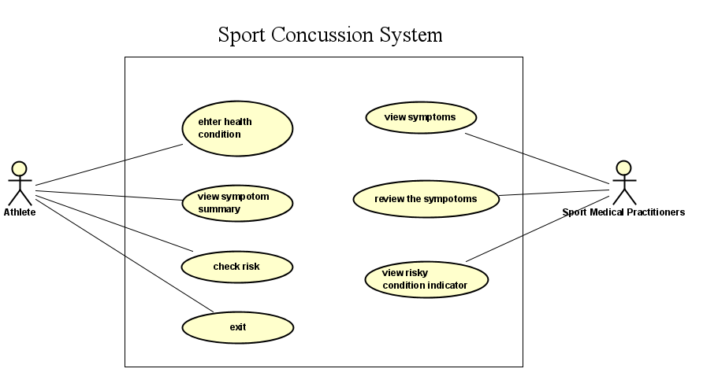

**Phase II, Part 1**

Include your use-case descriptions on this page. You may use add pages if necessary.

**Use Case Description for Athlete:**

|  |  |
| --- | --- |
| **Use case name** | Enter health condition |
| **Description** | Athlete enter the severity level of the symptoms from twenty-two factors to add to system |
| **Primary** Actor | Athlete |
| **Basic Flow** | Athlete chooses to enter symptom(option1), they will be prompted to enter the twenty-two possible symptoms with their severity level from zero to six. If the entered option number is less than 0 or greater than 4, then athlete will be prompted to enter again until correct input. If the entered the severity value is less than zero or greater than six, then they will be prompted to enter again. If there are more than five records in system, then delete the earliest before adding. |

|  |  |
| --- | --- |
| **Use case name** | View summary |
| **Description** | Athlete view the symptoms summary based on entered health condition |
| **Primary Actor** | Athlete |
| **Basic Flow** | Athlete chooses to display the symptom summary (option2), then a symptoms summary related to the most recent entered the record will be displayed. If the entered option number is less than 0 or greater than 4, then athlete will be prompted to enter again until correct input. |

|  |  |
| --- | --- |
| **Use case name** | Check if at risk |
| **Description** | Athlete needs to check if they are at risk based on their previously entered records |
| **Primary Actor** | Athlete |
| **Basic Flow** | Athlete chooses to check if at risk (option4), then result of risky condition indicator will be displayed one of three difference colors in text represents the severity of symptoms of last two successive games respectively. If the entered option number is less than 0 or greater than 4, then athlete will be prompted to enter again until correct input. |

**Use Case Description for Sport Medical Practitioner:**

|  |  |
| --- | --- |
| **Use case name** | View the athlete symptom summary |
| **Description** | SMP needs to review the symptom summary based on the health condition entered by athletes |
| **Primary Actor** | Sport Medical Practitioner |
| **Basic Flow** | SMP chooses to display the symptoms summary of an athlete, then a summary of health condition of an athlete based on the most recent entered record will be displayed. |

|  |  |
| --- | --- |
| **Use case name** | View the risky condition indicator |
| **Description** | SMP needs to check if an athlete at risk based on last two successive game’s symptoms |
| **Primary Actor** | Sport Medical Practitioner |
| **Basic Flow** | SMP chooses views the risky condition indicator (check if at risk), then the risky condition indicator will show a color in text the represents the severity of an athlete about their health condition. |

**Phase II, Part 2**

Use the use-case scenarios from Part 1 to identify and list the potential objects in the provided space. Use the template provided to create a CRC diagram for each object. Use as many pages as necessary for your CRC diagrams.

**Potential Objects:**

* **Roles:** 
  + **Athlete,**
  + **Sport Medical Practitioner**
* **Events:** 
  + **Add athletes**
  + **Athletes input symptoms,**
  + **Athletes review the symptom summary for each game**
  + **Athlete check if I am at risk**
  + **Sport Medical Practitioner view the symptoms summary**
  + **Sport Medical Practitioner view risky condition indicator for each athlete**
* **Things:** 
  + **Symptoms summary**
  + **Symptoms record**
  + **Risky condition indicator**
* **Organizational units:**
  + **Sport Concussion Assessment UI**

|  |  |
| --- | --- |
| **Class:**  SCAS_UI | **Collaborators**  Athletes Sport Medical Practitioner |
| **Responsibilities**  Display Menu  Call collect_symptoms  Call current_symptoms_summary  Call if_at_risk |

|  |  |
| --- | --- |
| **Class:**  Athletes | **Collaborators**  Sport Concussion Assessment UI Symptom record Sport Medical Practitioner |
| **Responsibilities**  Add athletes  Athletes input symptoms  Athlete review symptom summary for each game  Athlete check if I am at the risk |

|  |  |
| --- | --- |
| **Class:**  Sport Medical Practitioner | **Collaborators**  Athletes  Symptom record |
| **Responsibilities**  SMP views the symptom summary of an athlete for one game  SMP views risky condition indicator for each athlete |

|  |  |
| --- | --- |
| **Class:**  Symptom Record | **Collaborators**  Athletes |
| **Responsibilities**  Record the input symptoms from athletes |

**Phase II, Part 3**

1. Use Astah to draw the class diagram using object identified in part 2. Use proper UML notations to reflect relationship among objects.
2. When you have completed your diagram, take a clear screenshot of your diagram and paste it in provided space. Include your UML class diagram in the provided space.

